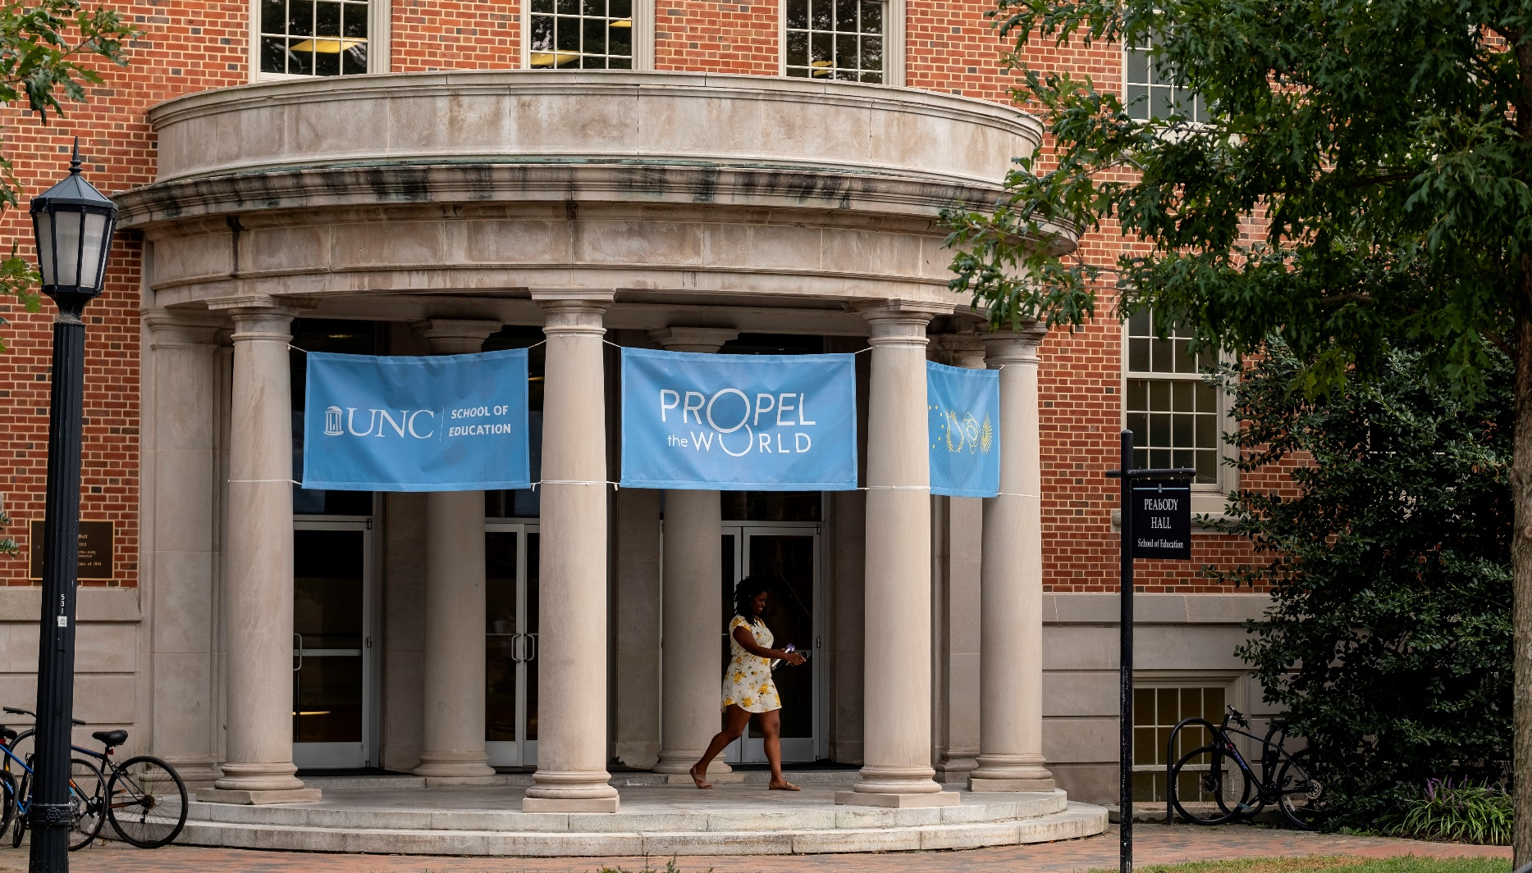

Title of Event in Le Monde Livre Bold Goes Here
ADDITIONAL INFORMATION IN ACUMIN PRO LIGHT CAN GO HERE
AND HERE

* To switch image above, right click and “Change Picture.”
** Do NOT cover Propel the World and icon graphics in lower right corner.
*** When exporting, for viewers to see the background design
with no transparency, this flyer must be saved as a PDF.

